**Hornby Products Company Case Summary**

**Parameters:**

We read each exhibits as our parameters(transportation unit costs, demands and warehouse costs)

**Decision Variables:**

**Objective function:**

**Constraints:**

**Solution:**

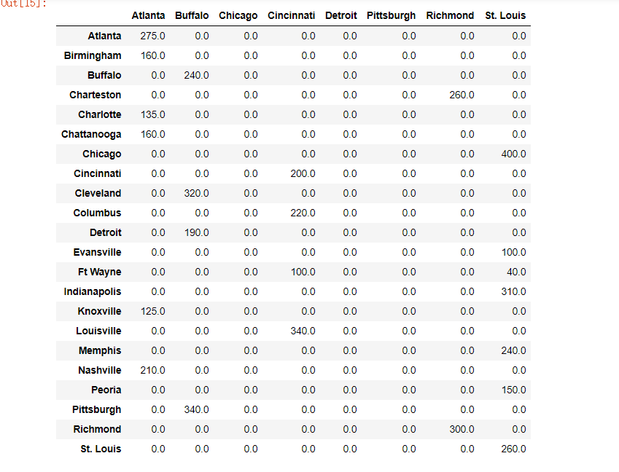

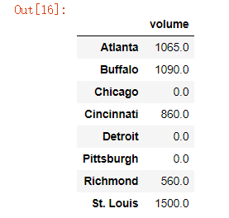**(Group by each warehouses)**

**Recommendation:**

**Code**

**Load Data**

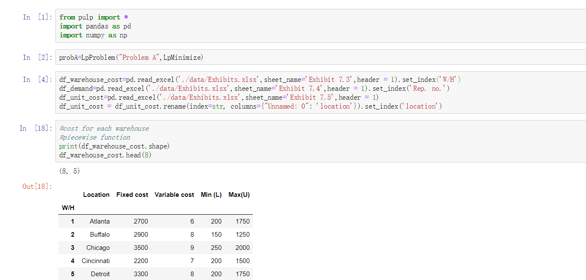

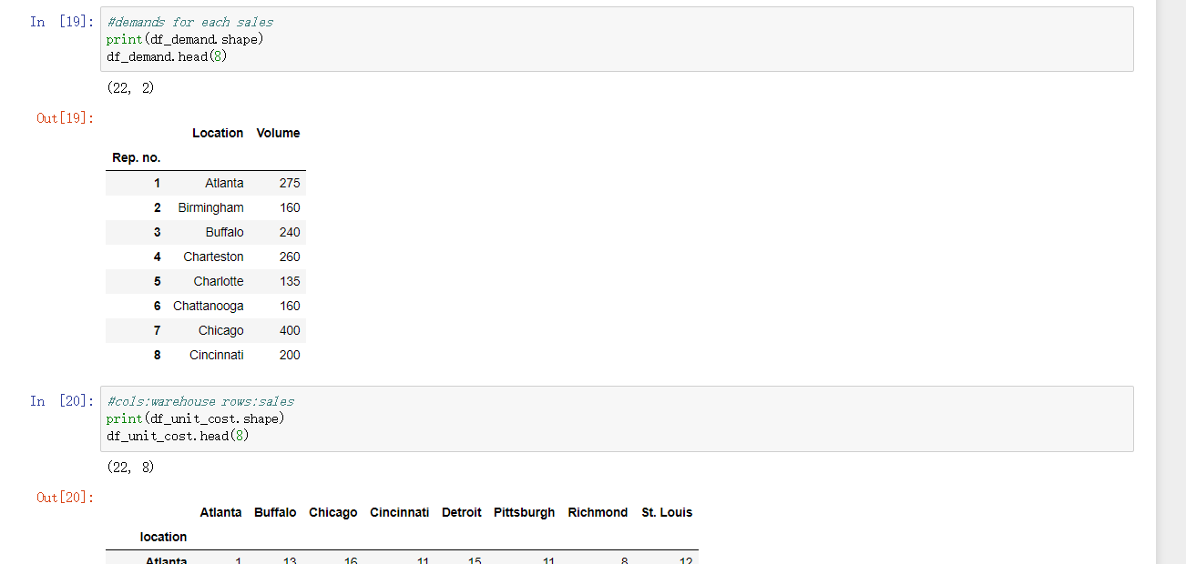

Parameters, Decision Variables, Objective and Constraints

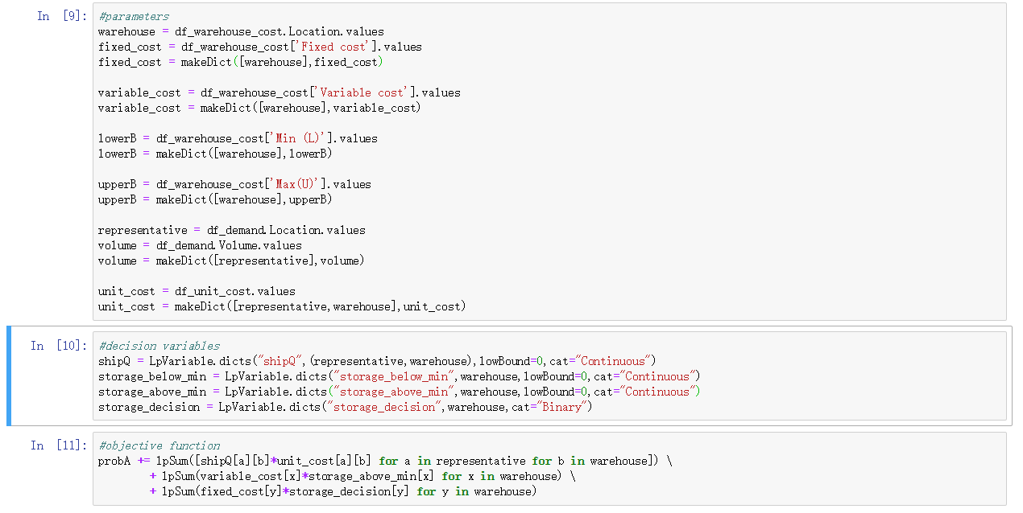

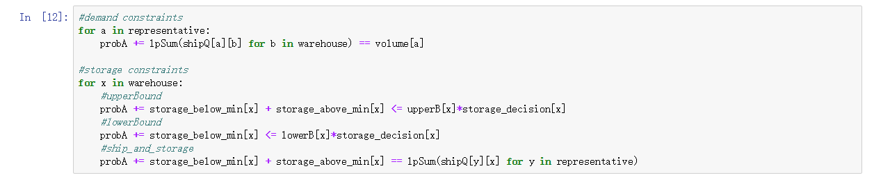

Solution

